GRM for TransT

Abstract
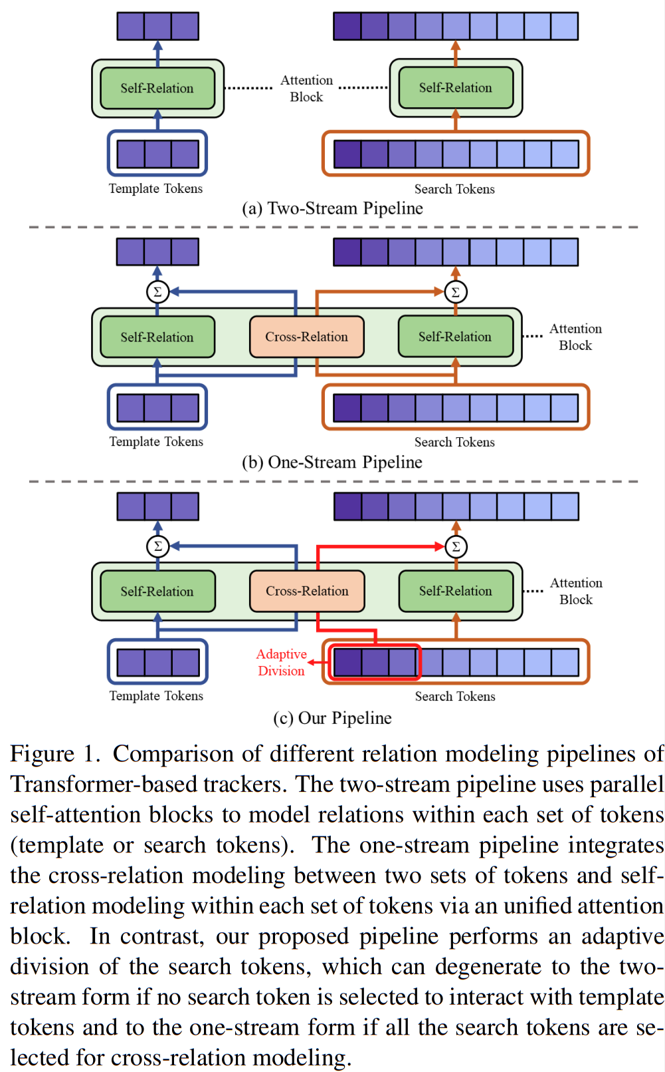
To alleviate this issue, we propose a generalized relation modeling method based on adaptive token division. The proposed method is a generalized formulation of attention-based relation modeling for Transformer tracking, which inherits the merits of both previous two-stream and one-stream pipelines whilst enabling more flexible relation modeling by selecting appropriate search tokens to interact with template tokens. An attention masking strategy and the Gumbel-Softmax technique are introduced to facilitate the parallel computation and end-to-end learning of the token division module. Extensive experiments show that our method is superior to the two-stream and one-stream pipelines and achieves state-of-the-art performance on six challenging benchmarks with a real-time running speed.

Intro
In this paper, we answer this question by proposing GRM, a generalized relation modeling method that can adaptively select the appropriate search tokens to interact with the template. To be specific, we classify the template and search tokens as three categories.
The template tokens form one category while the search tokens are divided into another two categories.
Instead of modeling relations within all the tokens as the one-stream pipeline, we restrict the interaction among the three token categories. Only the search tokens that are suitable for cross-relation modeling will interact with the template tokens, whilst the interaction between the remaining search tokens and the template tokens is blocked. With proper divisions, the two-stream pipeline and one-stream pipeline become two degenerated forms of our relation modeling method as discussed in Sec. 3.2. Consequently, our method is a generalized formulation of attention-based relation modeling for Transformer tracking, which embraces the advantages of both previous pipelines while being more flexible.
The search token division is performed by a lightweight prediction module, which can adaptively determine which search tokens are suitable for cross-relation modeling based on the input tokens. To accomplish this objective, there are two obstacles to overcome.
First, the separate relation modeling for different token categories makes it hard for parallel computation.
Second, the discrete token categorization is non-differentiable, thus impeding the end-to-end learning of the token division module. To facilitate parallel computation, we adopt an attention masking strategy to unify the individual attention operations into a single one. Additionally, we introduce the Gumbel-softmax technique to make the discrete token categorization differentiable.
Consequently, the search token division module can be implicitly optimized in an end-to-end manner, which promotes its adaptability to deal with different situations.
In summary, our main contributions are three-fold:
- We present a generalized formulation of relation modeling for Transformer trackers, which divides the input tokens into three categories and enables more flexible interaction between the template and search region.
- To realize the generalized relation modeling, we devise a token division module to adaptively classify the input tokens. An attention masking strategy and the Gumbel-Softmax technique are introduced to facilitate the parallel computation and end-to-end learning of the proposed module.
- We conduct extensive experiments and analyses to validate the efficacy of our method. The proposed GRM exhibits outstanding results on six challenging visual tracking benchmarks.

Method
The input of the one-stream pipeline is a pair of images, namely template z ∈ ℝ^{Hz×Wz×3} and search region x ∈ ℝ^{Hx×Wx×3}. They are first divided into N_{z} and N_{x} non-overlapping image patches of resolution P × P respectively, N_{z} = H_{z}W_{z}/P² and N_{x} = H_{x}W_{x}/P². Then, a linear projection is applied to these image patches to generate template patch embeddings E_{z} ∈ ℝ^{Nz×C} and search patch embeddings E_{x} ∈ ℝ^{Nx×C}, , where C is the embedding dimension. Next, two learnable position embeddings are added to E_{z} and E_{x} respectively to embed the spatial information. With some abuse of notation, we still refer to the two updated embeddings as E_{z} and E_{x}, which are the initial token embeddings of the template and search region, respectively. Afterward, all these tokens are concatenated as a sequence with a length of N_{z} + N_{x} and fed to an encoder. Each encoder layer updates the input tokens via a multi-head attention (MHA) block and a feed-forward network (FFN). Formally, the operations of the l-th encoder layer can be expressed as:
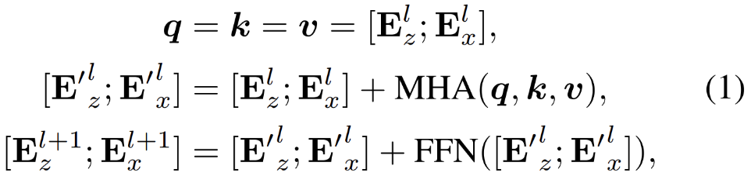
where E^{l}_{z} and E^{l}_{x} are the input tokens of the l-th encoder layer, and [;] denotes the concatenation operation. We use q,k and v to represent the queries, keys and values fed to the multi-head attention block. Since the template and search tokens are jointly processed by the multi-head attention block, the cross-relation and self-relation modeling are seamlessly integrated in each encoder layer. Finally, the output search tokens from the last encoder layer are decoupled from the template tokens and re-shaped to a 2D feature map according to their original spatial positions. The feature map is then taken as the input of to a convolutional head for target bounding box prediction.

